
Name : Tahir Fareed
Roll No: SU92-BSAIM-F24-036
Program: BSAI (3-A)
Lab :10

Data Analysis & Exploration

Overview
This document explains the steps performed in the Jupyter notebook LAB 10. The code focuses on loading a dataset, exploring its structure, and performing basic data analysis operations using Python libraries such as Pandas, NumPy, and Scikit-learn.

Code Explanation
Code:
# !pip install pandas
import pandas as pd
import numpy as np
from sklearn.preprocessing import LabelEncoder
Explanation:
This code block performs operations related to data loading, previewing, and understanding the dataset structure.

Code Explanation
Code:
df = pd.read_csv("used_cars.csv")
df
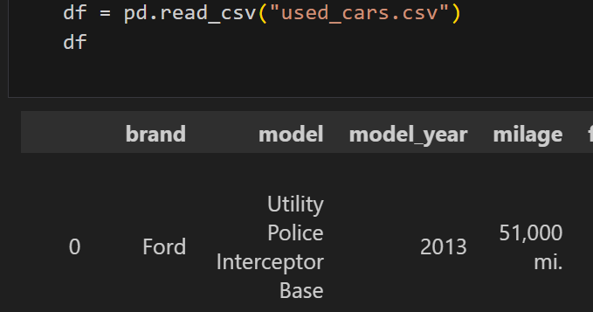
Explanation:
This code block performs operations related to data loading, previewing, and understanding the dataset structure.

Code Explanation
Code:
df.head(2)
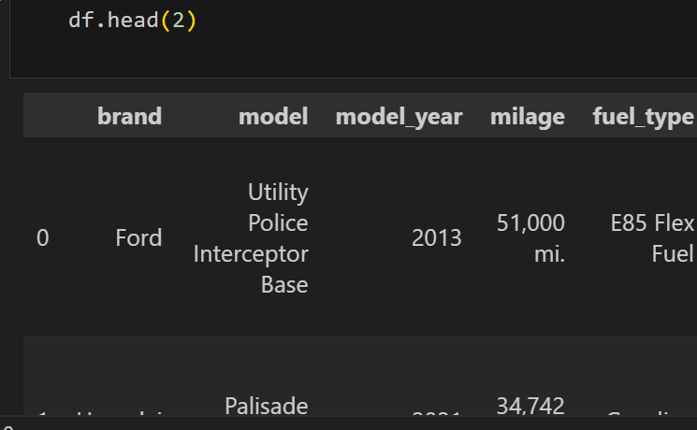
Explanation:
This code block performs operations related to data loading, previewing, and understanding the dataset structure.

Code Explanation
Code:
df.tail(2)
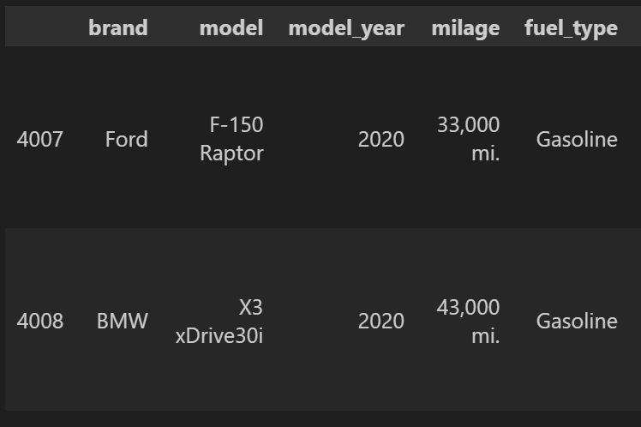
Explanation:
This code block performs operations related to data loading, previewing, and understanding the dataset structure.

Code Explanation
Code:
df.columns
# for cols in df.columns:
# print(cols)
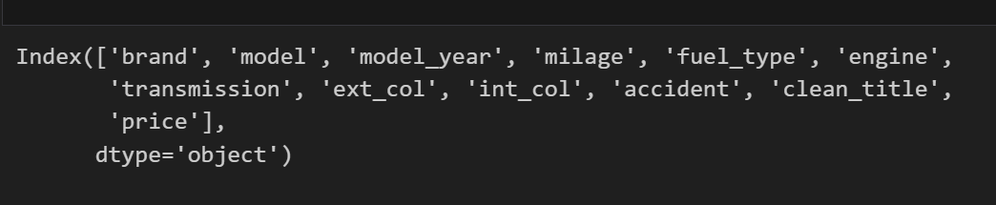
Explanation:
This code block performs operations related to data loading, previewing, and understanding the dataset structure.

Code Explanation
Code:
df.count()
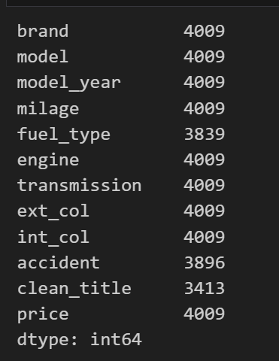
Explanation:
This code block performs operations related to data loading, previewing, and understanding the dataset structure.

Code Explanation
Code:
df.describe()
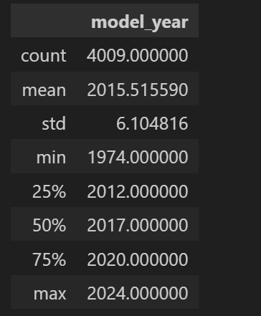
Explanation:
This code block performs operations related to data loading, previewing, and understanding the dataset structure.

Code Explanation
Code:
df.info()
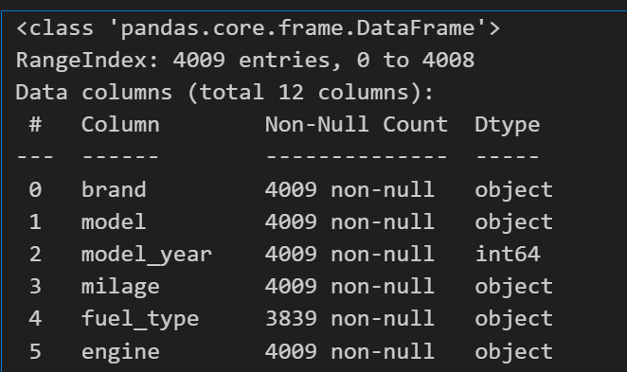
Explanation:
This code block performs operations related to data loading, previewing, and understanding the dataset structure.

Code Explanation
Code:
df.shape
print(f"Number of Rows: {df.shape[0]} and Number of Columns: {df.shape[1]}")
Explanation:
This code block performs operations related to data loading, previewing, and understanding the dataset structure.

Code Explanation
Code:
df.nunique()
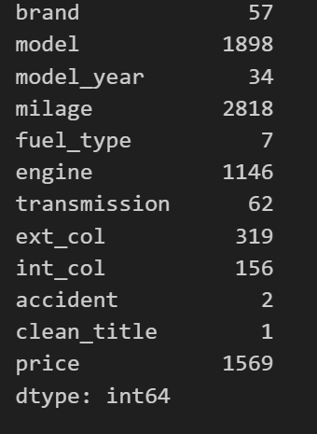
Explanation:
This code block performs operations related to data loading, previewing, and understanding the dataset structure.

Code Explanation
Code:
df.isnull().sum()
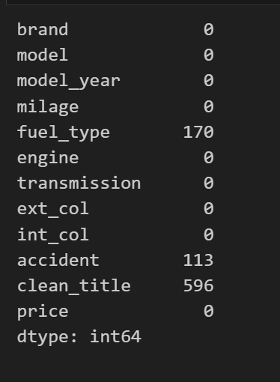
Explanation:
This code block performs operations related to data loading, previewing, and understanding the dataset structure.

Code Explanation
Code:
# df.drop('date', axis=1, inplace=True)
df = df.drop('model', axis=1)
Explanation:
This code block performs operations related to data loading, previewing, and understanding the dataset structure.

Code Explanation
Code:
# df.drop('country', axis=1, inplace=True)
df = df.drop('price', axis=1)
Explanation:
This code block performs operations related to data loading, previewing, and understanding the dataset structure.

Code Explanation
Code:
# Mean, Median, Mode
# df['price'].mean()
# df['price'].median()
# df['price'].mode()[0]
Explanation:
This code block performs operations related to data loading, previewing, and understanding the dataset structure.

Code Explanation
Code:
# df['model'].fillna(df['model'].mode()[0], inplace=True)
# df['model'] = df['model'].fillna(df['model'].mode()[0])
Explanation:
This code block performs operations related to data loading, previewing, and understanding the dataset structure.

Code Explanation
Code:
# For Int Type
def fillnaIntMode(cols):
for i in cols:
df[i] = df[i].fillna(df[i].mode()[0])
columns = ['model_year','brand','milage','int_col']
fillnaIntMode(columns)
Explanation:
This code block performs operations related to data loading, previewing, and understanding the dataset structure.

Code Explanation
Code:
# For Float Type
def fillnaFloatMean(cols):
for i in cols:
df[i] = df[i].fillna(df[i].mean())
columns = ['model_year']
fillnaFloatMean(columns)
Explanation:
This code block performs operations related to data loading, previewing, and understanding the dataset structure.

Code Explanation
Code:
df.info()
Explanation:
This code block performs operations related to data loading, previewing, and understanding the dataset structure.

Code Explanation
Code:

Explanation:
This code block performs operations related to data loading, previewing, and understanding the dataset structure.
